PROMPT REGISTRY — SCHEMA DESIGN
A Learning Log
Everything we reasoned through, in order — the problem, the questions, your answers, the corrections, and where the design stands now.

1. The Problem Statement
The goal is to build a prompt registry and evaluation system with three parts:
- A prompt registry in Postgres. Prompts are versioned rows, not hardcoded strings. You can diff versions and roll back.
- A golden set. 100+ labeled examples used as a fixed benchmark to grade prompts against.
- An eval runner. For any prompt version, it reports accuracy, average cost, and p95 latency.
p95 latency = the latency the slowest 5% of requests experience. More honest than an average, because tail latency is what users actually complain about.
Learning approach: Instead of being handed the schema, each design decision was derived by reasoning from the failure it prevents. This log preserves that reasoning.

2. The Questions, My Answers, and the Corrections

Grouping versions of the same prompt
Q1. If sentiment-classifier has v1/v2/v3 and summarizer has v1/v2, what column tells the two families apart?
My answer: A logical_prompt_group column (a family name shared across all versions).
Verdict: Correct. This is the 'name' / 'prompt_key' — shared across every version of one logical prompt.
Q2. Does the schema capture which version is live right now, and how would you mark it?
My answer: An is_active_version boolean column.
Verdict: Right idea — but a plain boolean alone lets TWO versions be active at once. Needs a constraint to enforce 'exactly one active per family'.

Enforcing uniqueness
Q3. What database feature enforces that the combination of name + version must be unique?
My answer: A composite key / unique index across multiple columns.
Verdict: Correct. A composite UNIQUE constraint — UNIQUE (name, version) — backed by a unique index. It's the PAIR that's locked, not either column alone.
Q4. How do you enforce 'only one active version per family' when a plain UNIQUE(name, is_active) fails?
My answer: A unique index on the family name, but only for rows where is_active is true.
Verdict: Correct. A PARTIAL unique index: UNIQUE (name) WHERE is_active = true. The inactive rows aren't indexed, so they never collide.

Version vs. session — a concept correction
Q5. Is a version basically the session of the prompting?
My answer: Thought version might mean the session / a run of prompting.
Verdict: No — important correction. A VERSION is a saved revision of the prompt text (like a git commit): static, human-edited. A RUN is one time you tested a version against the golden set. One version → many runs.

The golden set — what one example points to
Q6. Does a golden example point to the family or a specific version, and why?
My answer: The family — because the golden set has to be reused across multiple versions.
Verdict: Correct. The golden set is the fixed ruler; it must stay constant so v2 and v3 are graded on the same examples.
Q7. What is the foreign key on a golden_examples row?
My answer: First said a composite FK of (family + version / prompt_text). After pushback: a single FK to the family only.
Verdict: Corrected to right answer. ONE column pointing at the family. No version, no prompt_text — otherwise the example gets pinned to a single draft, contradicting Q6.
Q8. Two columns (input, expected_output) — do they handle both a sentiment classifier (exact match) and a summarizer (paragraph, never matches exactly)?
My answer: First answered 'family is missing'. Actual gap: they don't tell the runner HOW to compare output to expected.
Verdict: Re-aimed. The missing piece is a match_type / grader column — a CONSTRAINED enum (exact, contains, semantic), not free text — so the runner knows which comparison method to apply per example.
Q9. Should every example always be usable, or do you sometimes exclude one from a run?
My answer: Not always — use an is_active column so only active examples run.
Verdict: Correct, and you spotted the reused pattern. Note: here is_active is a plain filter (MANY active at once) — no uniqueness constraint, unlike the version's is_active.
Q10. If you add 40 examples later, runs become non-comparable. Does the golden set need to record which examples existed at run time?
My answer: Yes — we need the notion of which examples were used when a run happened.
Verdict: Correct instinct. Still an OPEN decision on the mechanism (snapshot of ids / join table / timestamps). To be resolved before building.

3. The Schema We Derived
Splitting families and versions into separate tables kept solving problems — it gave every foreign key a single, clean id to point at, and gave every constraint a natural home.

Table overview
Table | One row = | Key columns
prompts | one prompt family | id (PK), name (unique)
prompt_versions | one saved version of a prompt | id (PK), prompt_id (FK), version, prompt_text, is_active
golden_examples | one labeled test example | id (PK), prompt_id (FK), input, expected_output, match_type, is_active
eval_runs | one test of one version | id (PK), version_id (FK), accuracy, avg_cost, p95_latency

The relationships (FK arrows)
- prompt_versions → prompts (many versions belong to one family)
- golden_examples → prompts (examples point at the FAMILY, never a version)
- eval_runs → prompt_versions (a run tests one specific VERSION)
The distinction to never slip on: golden_examples connect to the family; eval_runs connect to the version.

The constraints, and the failure each prevents
Constraint | Lives on | Prevents
Surrogate id primary key | every table | clumsy composite keys in FKs
UNIQUE (name) | prompts | duplicate families
UNIQUE (prompt_id, version) | prompt_versions | same version saved twice in a family
Partial unique: UNIQUE(prompt_id) WHERE is_active | prompt_versions | two versions live at once
match_type as enum/CHECK | golden_examples | unknown or typo'd grading methods

The match_type column
A constrained set (enum or CHECK), because the runner only implements a fixed handful of comparison methods:
- exact — string equality (e.g. sentiment: "positive")
- contains — expected value appears somewhere in the output
- semantic — similarity above a threshold (e.g. summaries)

4. Open Decisions (resolve before building)
1. How a run records which examples it used (from Q10). Options: snapshot the example ids into the run, a run_examples join table, or rely on created_at / run_at timestamps. The join table most reliably reconstructs 'exactly what v2 was graded on last March'.
2. Where the semantic similarity threshold lives. On the example row (per-example strictness), on the run, or as global config?
3. Version column type. An integer makes 'get the latest version' trivial; a free string makes sorting painful.

5. Schema Evolution — Every Version, Every Fix
The diagram went through five iterations. Each one fixed the previous version's flaw but often exposed a new one. This is the trail, so you can see exactly what was wrong and why the fix worked.

V1 — First sketch (single registry table only)
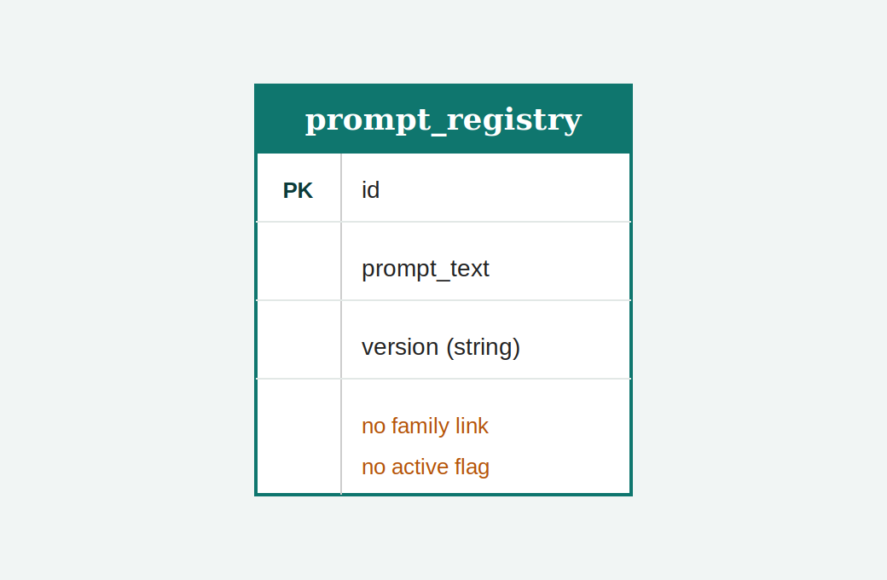
What was right: Started with the right core idea: prompts as versioned rows with id, prompt_text, version.
The problem(s):
- No column grouped versions of the same logical prompt together — sentiment-classifier v1/v2/v3 and summarizer v1/v2 couldn't be told apart.
- No way to mark which version is currently live, so 'roll back' had no anchor.
- version was a free string, making 'get the latest' painful.
The fix: Add a family identifier (name), an is_active marker, and treat version as sortable. This later became a decision to split families into their own table.
(V1 was described in text, not drawn — shown here as a reconstruction.)

V2 — Four tables (PromptRegistry, PromptFamily, Evalrunner, GoldenSet)
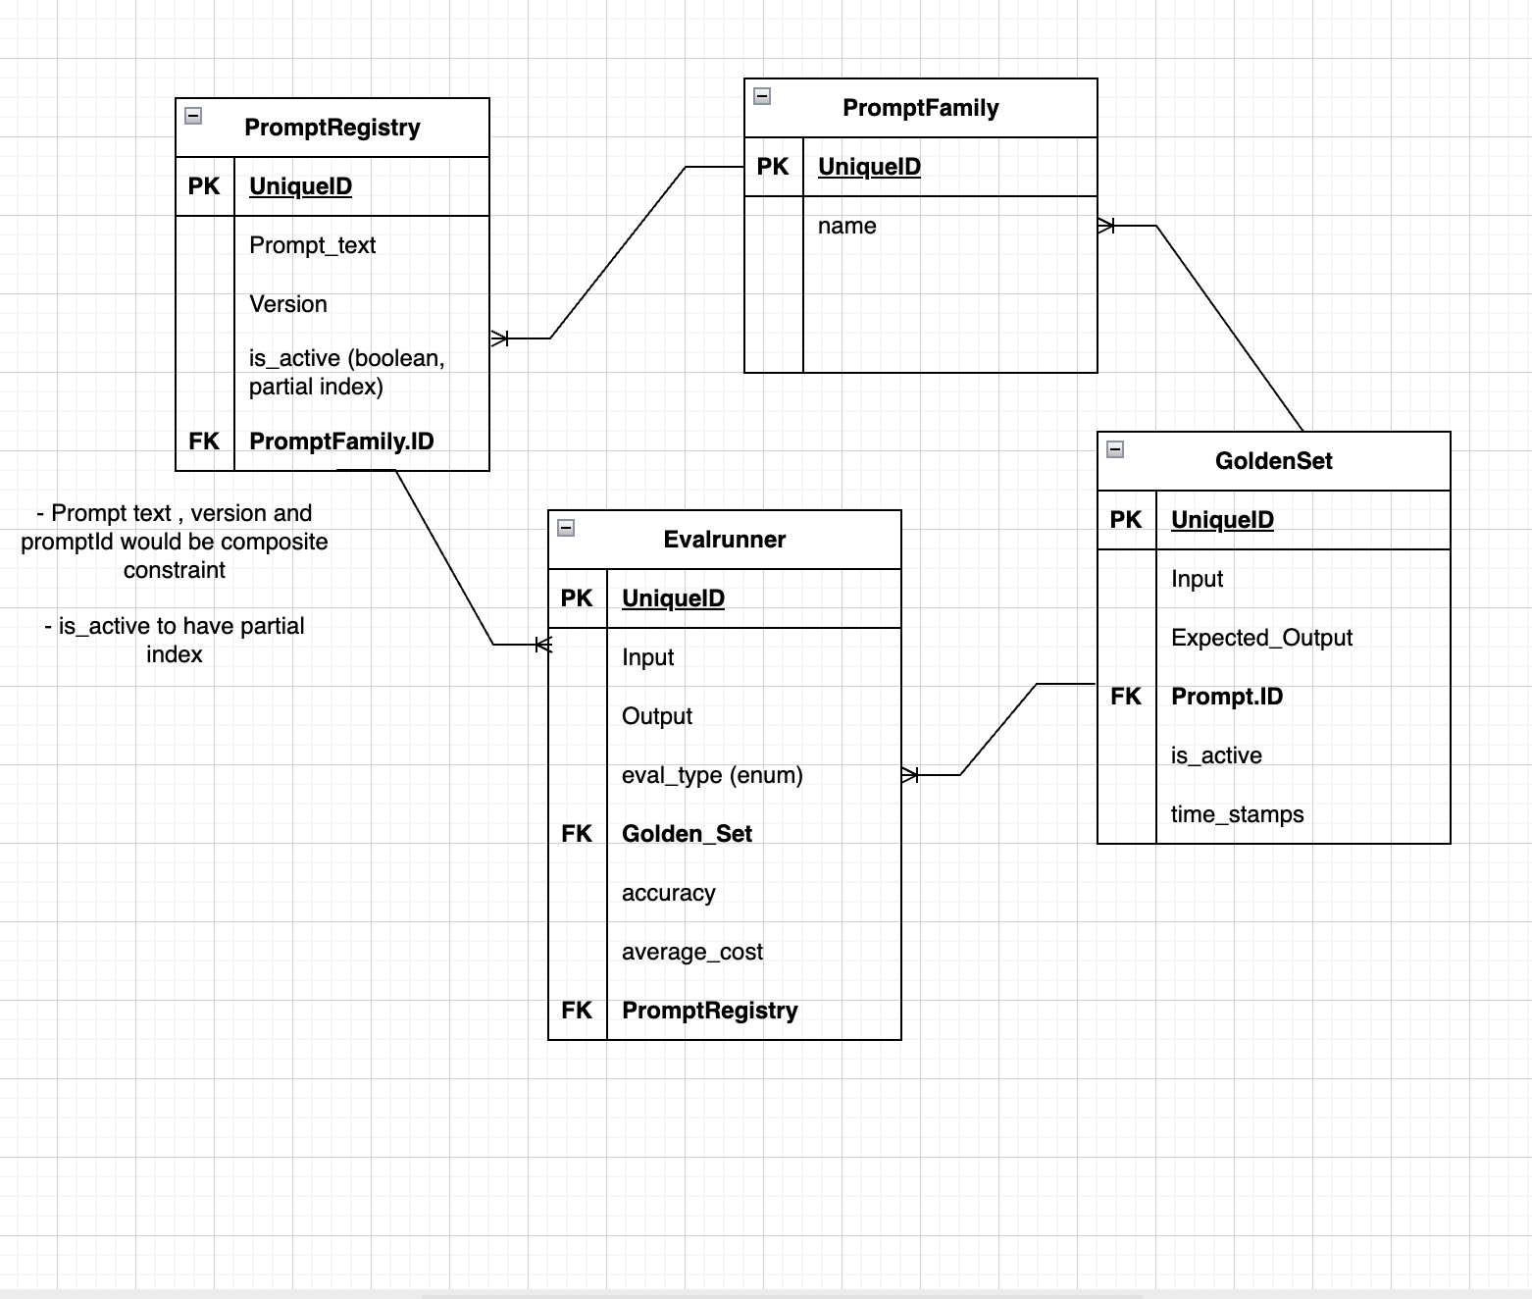
What was right: Correctly split into four tables. Crucially, the two family-level FK arrows landed right: GoldenSet pointed at PromptFamily, and Evalrunner pointed at PromptRegistry (the version).
The problem(s):
- Evalrunner had the WRONG grain — it mixed single-example fields (Input, Output, eval_type) with whole-run aggregates (accuracy, average_cost) in one row. A row can't be both 'one example' and 'one whole run'.
- A single Golden_Set FK on Evalrunner tried to say 'this run used 100 examples' — impossible, one FK points at one row.
- p95_latency was missing entirely — the one metric singled out as the whole point.
- The actual model output had no home. GoldenSet holds expected output; the fresh actual output produced each run had nowhere to live.
- Annotation suggested prompt_text belonged in the composite unique constraint — it shouldn't (a text typo-fix shouldn't require a version bump).
The fix: Recognize that 'one run' and 'one graded example' are different grains and need different tables. This forced the creation of a per-example results table.

V3 — Added EvalResults table
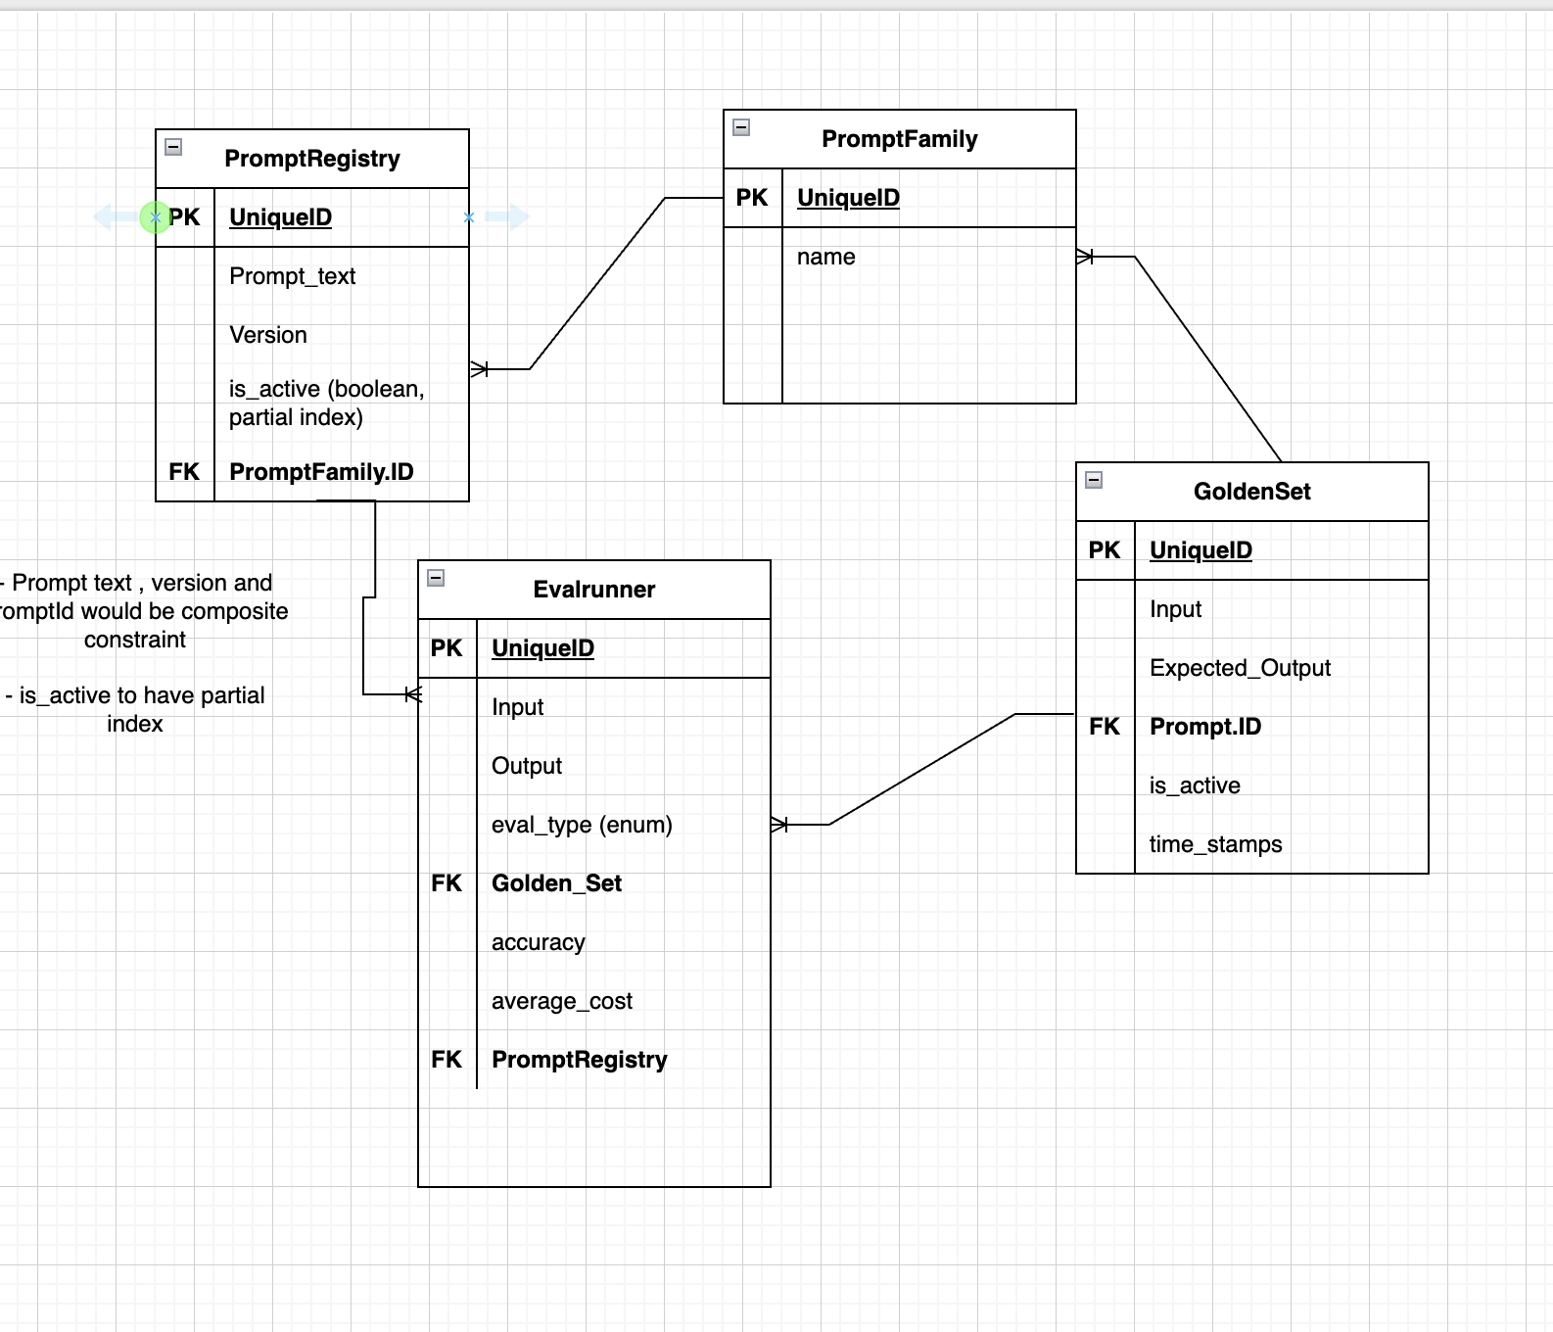
What was right: Added the missing join table (EvalResults) with both FKs — EvalRunner.ID (which run) and GoldenSet.ID (which example). Moved p95_latency onto Evalrunner. All three metrics now present.
The problem(s):
- EvalResults had Input AND Output — the Output (actual) is correct, but a plain 'Input' duplicated GoldenSet's input (reachable via FK). Only justified if it means the fully-rendered prompt, and then it should be named distinctly.
- eval_type (the match method) was still sitting on Evalrunner — wrong grain. Different examples in one run may need different grading methods.
- EvalResults had no per-example metrics (passed, cost, latency), so Evalrunner's aggregates had nothing to roll up FROM.
- No 'passed' / score column anywhere — yet accuracy is defined as the fraction of examples that passed.
The fix: Add passed, cost, latency at the per-example grain on EvalResults; move eval_type down off the run.

V4 — Added cost & latency to EvalResults (current)
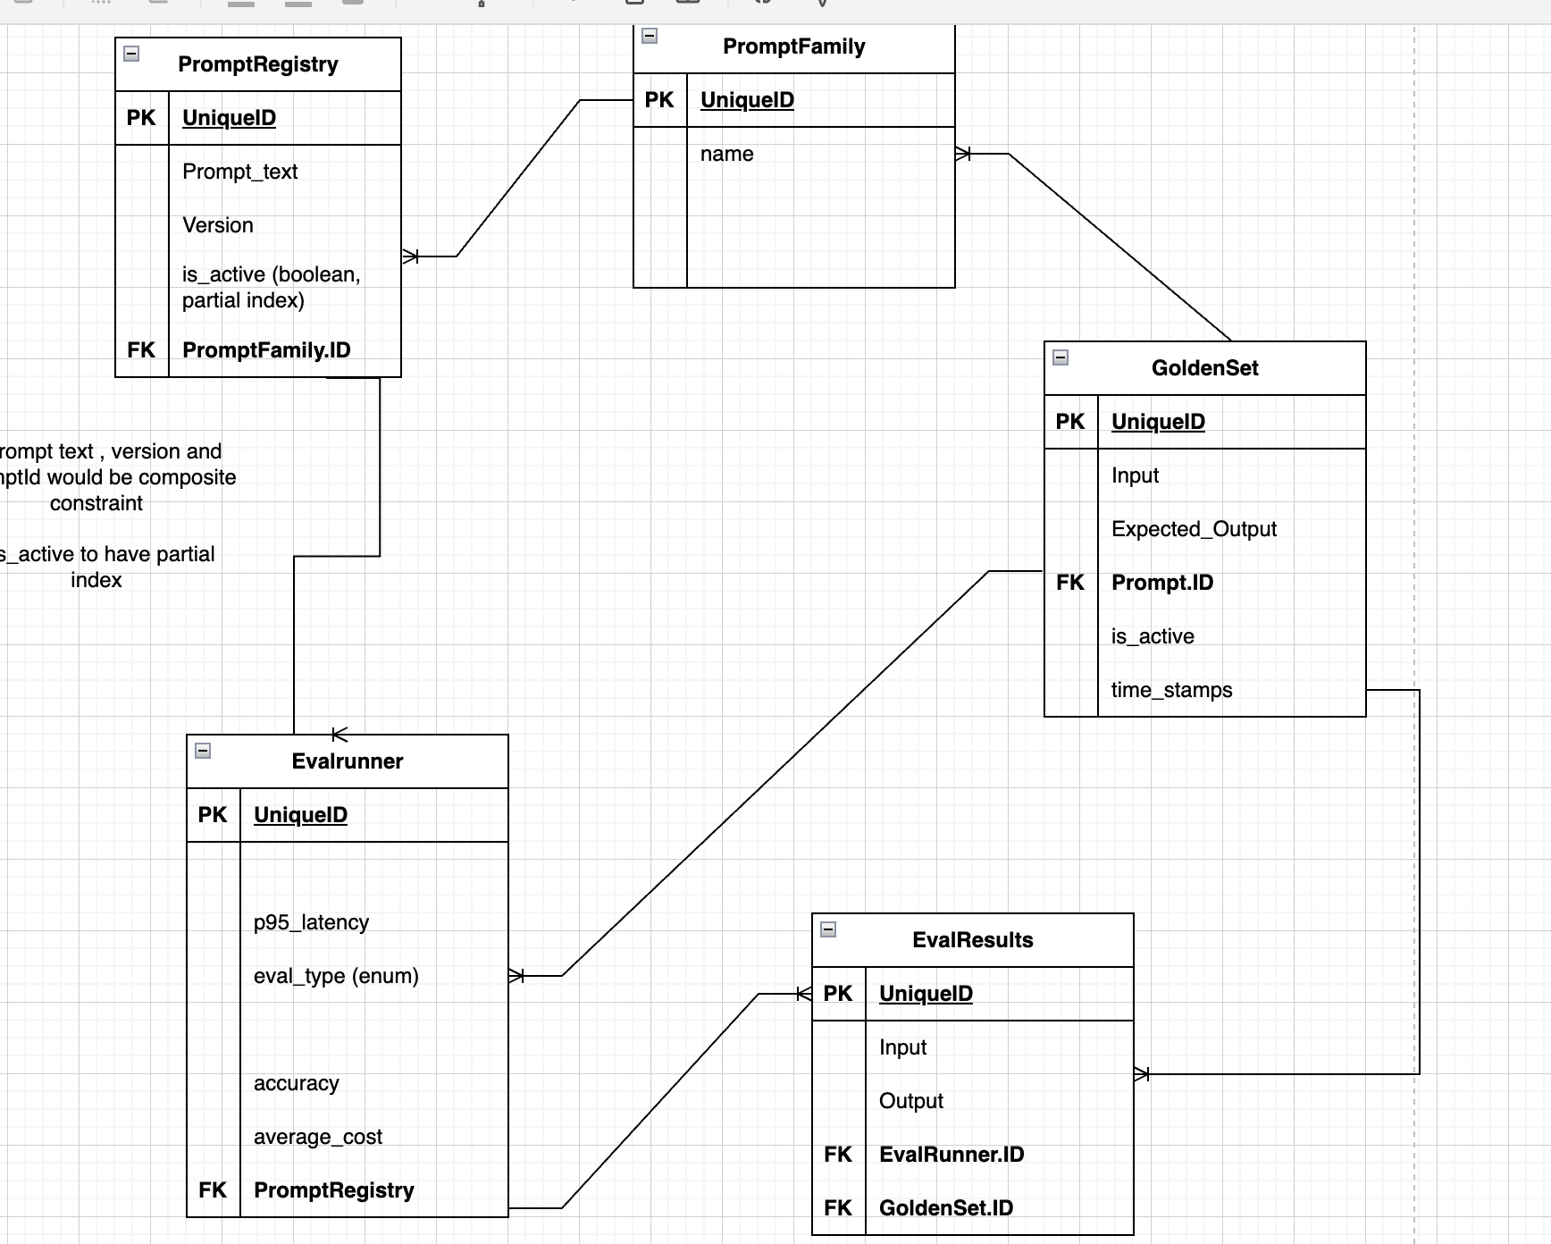
What was right: Added the raw per-example cost and latency to EvalResults — exactly the ingredients the run-level average_cost and p95_latency are computed from.
The problem(s):
- Over-corrected: EvalResults now ALSO carries p95_latency, accuracy, and average_cost — but those are aggregates that describe a whole run, not a single example. 'accuracy' is meaningless for one example (it passed or it didn't).
- The same three aggregate columns now appear in BOTH Evalrunner and EvalResults — duplication across grains.
- passed is still missing — the true/false that accuracy counts up.
- eval_type is still on Evalrunner, not yet moved down.
The fix: Strip the aggregates (accuracy, average_cost, p95_latency) OUT of EvalResults — they belong only on Evalrunner. Add passed to EvalResults. Move eval_type to the example grain.

The target end state (what 'done' looks like)
Evalrunner (one row = one whole run):
- UniqueID (PK)
- PromptRegistry FK (which version was tested)
- accuracy, average_cost, p95_latency — all rolled up from EvalResults
EvalResults (one row = one example graded in one run):
- UniqueID (PK)
- EvalRunner.ID FK, GoldenSet.ID FK
- Output (actual model output) — and Input only if it means the rendered prompt
- passed, cost, latency — the raw per-example numbers
- eval_type (or on GoldenSet) — how this example is graded
The pattern across all versions: almost every bug was a GRAIN error — putting a per-example field on the run table, or a whole-run aggregate on the per-example table. The fix was always: ask 'what does one row of this table represent?' and move each column to the table whose grain matches.

6. Where We Stand Now
- Problem statement understood, including what p95 latency means and why it matters.
- Five-table design reached: PromptFamily, PromptRegistry (versions), GoldenSet, Evalrunner, EvalResults.
- All FK levels settled — GoldenSet → family, Evalrunner → version, EvalResults → both run and example.
- Grain understood: Evalrunner = whole run (aggregates); EvalResults = one example graded (raw numbers).
- Roll-up relationship clear: accuracy/average_cost/p95_latency computed FROM EvalResults' passed/cost/latency.
- Remaining cleanup: strip aggregates out of EvalResults, add passed, move eval_type to example grain.
Next step: Finalize V4 -> target state: remove aggregates from EvalResults, add passed, move eval_type to the example grain. Then translate the four (or five) tables into SQLAlchemy models and let Alembic generate the migration.
You derived every constraint from the failure it prevents — which is the way to actually retain it.

